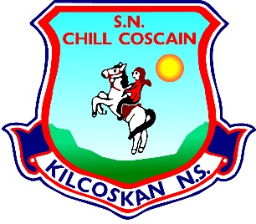
KILCOSKAN NATIONAL SCHOOL 2022-2023
Kilcoskan National School, Kilcoskan, The Ward, Co Dublin Ph: 01 8351508
www.kilcoskan.com

Third Class Booklist – Bookhaven Code: u1kt3c

Class books to be purchased by parents
Handwriting: Ready to Write E1 (Third Class)

Spelling: Spellbound 3 (Third Class) – CJ Fallon

English: Starlight Combined Reader & Skills Book - Folens

Maths: Cracking Maths Pupil Book (Third Class) - Gill and MacMillan
New Wave Mental Maths (Third Class)
Maths Table Book

Gaeilge: Bua Na Cainte 3 (Third Class) - Edco

SESE: Small World History (Fourth Class)
Small World Geography & Science (Fourth Class)
* 3rd class will need 4th class book this year.

- Please ensure all books and stationery are clearly labelled for the first day of school.
- Please ensure ALL uniform items, tracksuits, coats, hats etc are clearly labelled.
- Please ensure all school bags, lunch boxes and beakers are clearly labelled.

